Incident Investigation Report

Instructions: Complete this form as soon as possible after an incident that results in serious injury or illness. (Optional: Use to investigate a minor injury or near miss that could have resulted in a serious injury or illness.)

This is a report of a:  Death  Lost Time  Dr. Visit Only  First Aid Only  Near Miss
Date of incident: | This report is made by:  Employee  Supervisor  Team  Other_________

Step 1: Injured employee (complete this part for each injured employee)
Name: | Sex:  Male  Female |  | Age:
Department: | Job title at time of incident:
Part of body affected: (shade all that apply)  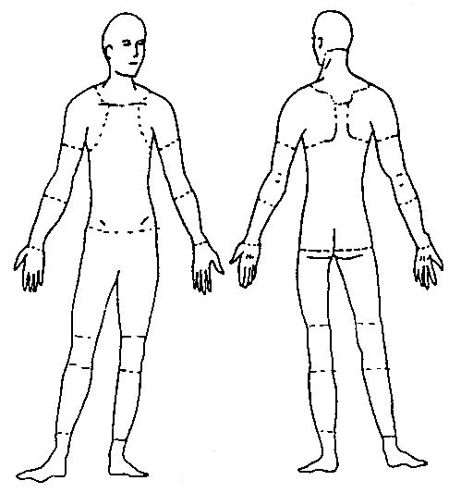 | Nature of injury: (most serious one)   Abrasion, scrapes   Amputation   Broken bone   Bruise   Burn (heat)   Burn (chemical)   Concussion (to the head)   Crushing Injury   Cut, laceration, puncture   Hernia   Illness   Sprain, strain   Damage to a body system:   Other ___________ | This employee works:   Regular full time   Regular part time   Seasonal   Temporary
Months with
this employer
Months doing
this job:

Step 2: Describe the incident
Exact location of the incident: | Exact time:
What part of employee’s workday?  Entering or leaving work  Doing normal work activities
❑ During meal period  During break  Working overtime  Other___________________
Names of witnesses (if any):

Number of attachments: | Written witness statements: | Photographs: | Maps / drawings:
What personal protective equipment was being used (if any)?
Describe, step-by-step the events that led up to the injury. Include names of any machines, parts, objects, tools, materials and other important details.

Description continued on attached sheets: 

Step 3: Why did the incident happen?
Unsafe workplace conditions: (Check all that apply)   Inadequate guard   Unguarded hazard   Safety device is defective   Tool or equipment defective   Workstation layout is hazardous   Unsafe lighting   Unsafe ventilation   Lack of needed personal protective equipment   Lack of appropriate equipment / tools   Unsafe clothing   No training or insufficient training   Other: _____________________________ | Unsafe acts by people: (Check all that apply)   Operating without permission   Operating at unsafe speed   Servicing equipment that has power to it   Making a safety device inoperative   Using defective equipment   Using equipment in an unapproved way   Unsafe lifting   Taking an unsafe position or posture   Distraction, teasing, horseplay   Failure to wear personal protective equipment   Failure to use the available equipment / tools   Other: __________________________________
Why did the unsafe conditions exist?
Why did the unsafe acts occur?
Is there a reward (such as “the job can be done more quickly”, or “the product is less likely to be damaged”) that may have encouraged the unsafe conditions or acts?  Yes  No
If yes, describe:
Were the unsafe acts or conditions reported prior to the incident?  Yes  No
Have there been similar incidents or near misses prior to this one?  Yes  No

Step 4: How can future incidents be prevented?
What changes do you suggest to prevent this incident/near miss from happening again?

❑ Stop this activity  Guard the hazard  Train the employee(s)  Train the supervisor(s)

❑ Redesign task steps  Redesign work station  Write a new policy/rule  Enforce existing policy

❑ Routinely inspect for the hazard  Personal Protective Equipment  Other: ____________________

What should be (or has been) done to carry out the suggestion(s) checked above?

Description continued on attached sheets: 

Step 5: Who completed and reviewed this form? (Please Print)
Written by:  Department: | Title:  Date:
Names of investigation team members:
Reviewed by: |  | Title:  Date:

